Java Language

An Internship-(II) Report
Submitted in partial fulfillment of the requirement
for the degree of
Bachelor of Technology In Computer Science and Engineering
July-December 2024

Submitted by

ABHISHEK CHOUHAN
0704CS221005]


Department of Computer Science and Engineering
Mahakal Institute of Technology, Ujjain
Affiliated to Rajiv Gandhi Proudyogiki Vishwavidyalaya, Bhopal

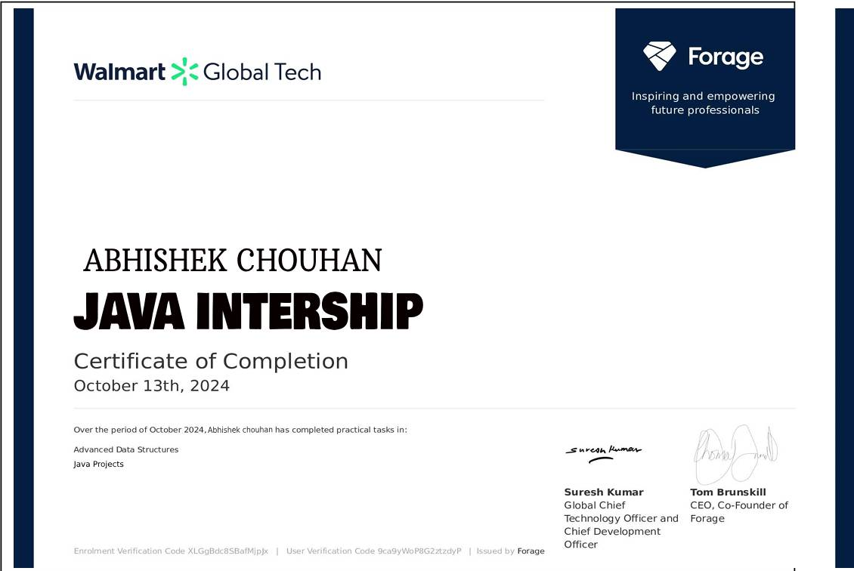

RECOMMENDATION

The Internship work entitled “Java” submitted by ABHISHEK CHOUHAN is recommended towards partial fulfillment for the award of the Bachelor of Technology in Computer Science and Engineering from Mahakal Institute of Technology, Ujjain by Rajiv Gandhi Prodyogiki Vishwavidyalaya, Bhopal.

Internship Coordinator Head
Prof. Sharad Morolia Department of Computer Science and Engineering
Date: 25/10/2024 Mahakal Institute of Technology, Ujjain

DECLARATION

I am ABHISHEK CHOUHAN of student hereby declare that I have undertaken 2 weeks internship work “WalMart” during a period from 1/10/2024 to 13/10/2024 in partial fulfillment for the award of the Bachelor of Technology in Computer Science and Engineering from Mahakal Institute of Technology, Ujjain by Rajiv Gandhi Prodyogiki Vishwavidyalaya, Bhopal. The work which is being presented in the internship report submitted to Department of Computer Science &
Engineering from Mahakal Institute of Technology, Ujjain, is an authentic record of training work.

Date:23/10/2024 ABHISHEK CHOUHAN
0704CS221005]

ACKNOWLEDGEMENT

I would like to express my deepest gratitude to all the individuals and institutions that have supported me throughout my journey of learning Java Language using Java. Their encouragement and guidance have been invaluable in enhancing my knowledge and skills in this cutting-edge technology.
First and foremost, I am immensely thankful to Awais Qurasi, whose expert knowledge, patience, and continuous support have been instrumental in shaping my understanding of Java and app development. Their insightful feedback and advice have guided me through the complexities of mobile development, helping me grow as a developer.
I would also like to extend my appreciation to WalMart for providing an excellent learning environment and the resources necessary to make this training successful. The tools, infrastructure, and hands-on approach have enriched my learning experience, allowing me to develop practical skills in building real-world mobile applications.
My heartfelt thanks go to my classmates and fellow developers, whose collaboration, discussions, and camaraderie made the learning process engaging and fun. The group efforts and knowledge sharing during our sessions not only deepened my understanding of Java but also motivated me to strive for excellence.
Lastly, I want to acknowledge the support of my family and friends. Their encouragement and belief in my abilities gave me the strength to overcome challenges and pursue this technical journey with confidence.
This report is a reflection of the collective efforts and wisdom I have received from everyone around me, and I am truly grateful for the positive influence they have had on my learning path.

ABHISHEK CHOUHAN
[ 0704CS221005]

ABOUT WALMART
WalMart is a prominent online and offline learning platform that specializes in providing highquality training in Mobile App Development, data science, big data, artificial intelligence (AI), machine learning (ML), and software development. It is dedicated to bridging the gap between academic learning and industry demands by offering courses that combine theoretical knowledge with practical, hands-on projects. With a focus on tools like Python, R, Hadoop, Apache Spark, and AI technologies, WalMart aims to equip learners with real-world skills that can be directly applied in the workplace. The platform offers a flexible, self-paced learning environment with lifetime access to course materials, ensuring that students can learn at their own pace and revisit concepts as needed. One of WalMart’s standout features is its emphasis on project-based learning, where students work on real-time scenarios that help them apply concepts in practical contexts. Additionally, the platform provides career support through resume-building workshops, interview preparation, and certification programs that enhance job readiness. WalMart caters to a wide audience, from beginners and students to professionals looking to upskill or transition into tech roles. Its global reach and accessible pricing make it an attractive option for learners across the world who are looking to stay ahead in the competitive tech landscape.

TABLE OF CONTENTS
Page No.
Internship Certificate provided by the Company/Industry/Institute I
Recommendation II
Declaration III
Acknowledgement IV
About Company/Industry/Institute V
Table of Contents VI
Abstract VII
Figure Index VIII

Chapter 1 Introduction (1-4)
1.1 Introduction 1
1.2 Objective 2
1.3 Tools and Technology used 2

Chapter 2 Training Work Undertaken (5-11)
2.1 Java programming Language 5
2.2 Concept of OOPS 6
2.3 JDK (Java Development kit) 8

Chapter 3 Results and Discussion (8-14)
3.1 Currency Convertor Project 11
3.2 Attendance Management System 12

Chapter 4 Conclusion and Future Scope (15-16)
4.1 Conclusion 15
4.2 Future Scope 15

Appendix A Daily Diary 17-20

ABSTRACT

Java Languagehas evolved significantly with the introduction of cross-platform frameworks like Java. Developed by Google, Java allows developers to build natively compiled applications for Android, iOS, web, and desktop from a single codebase. This report focuses on the fundamentals of Java Languageusing Java, highlighting its widgetbased architecture, use of the Java programming language, and features like hot reload, which enable faster development and testing.
The report also covers key aspects such as layout design, state management, and Firebase integration for backend services. By providing a unified platform for building apps with a consistent user experience across devices, Java simplifies development and reduces time-tomarket. Practical examples demonstrate the versatility and power of Java in creating dynamic, high-performance mobile applications.
The Java Internship offers an immersive experience for aspiring mobile app developers to gain hands-on experience with Java, Google's open-source UI toolkit. This internship focuses on building cross-platform applications for Android, iOS, and the web, utilizing Java as the primary programming language. Interns will learn best practices in app design, development, and deployment, working closely with mentors to create responsive, high-performance, and visually appealing mobile applications

FIGURE INDEX
Figure No.

Title of Figure

Page No.

Fig 2.1 Concept of OPPS 8
Fig 2.2 Java code 10
Fig 3.1 input of currency convertor 11
Fig 3.2 output of currency convertor 12
Fig 3.3 input of attendance management system 13
Fig 3.4 output of attendance management system 14

Chapter 1 INTRODUCTION

1.1 INTRODUCTION:
Java Languagehas emerged as one of the most dynamic and lucrative fields in the technology landscape, revolutionizing how businesses and individuals interact with digital services. The increasing reliance on smartphones and mobile devices has led to a surge in demand for innovative and user-friendly applications. As users expect seamless experiences across multiple platforms, the need for frameworks that facilitate cross-platform development has become paramount.

Java, an open-source UI toolkit created by Google, has gained immense popularity among developers for its ability to streamline the app development process. Launched in 2017, Java enables developers to create natively compiled applications for mobile, web, and desktop from a single codebase, significantly reducing development time and effort. Its foundation in the Java programming language provides a robust and efficient platform for building high-performance applications with rich interfaces.

One of the key features of Java is its extensive widget library, which allows developers to build visually appealing and responsive UIs with ease. These widgets are designed to follow Material Design and Cupertino styles, ensuring that applications not only function well but also look aesthetically pleasing on both Android and iOS platforms. Moreover, Java’s Hot Reload feature enhances the development experience by allowing developers to see the results of their code changes in real time, fostering a more iterative and creative development process.

The architecture of Java emphasizes a reactive programming model, making it easier to manage the state of applications. This approach facilitates the creation of smooth and fluid user experiences, as developers can quickly update the UI in response to changes in application state.
Additionally, Java’s support for a wide range of libraries and packages extends its functionality, enabling developers to incorporate features like animations, network calls, and state management solutions without reinventing the wheel.
As mobile applications become increasingly complex, the importance of effective state management and seamless integration with backend services cannot be overstated. This report aims to explore the various facets of Java Languageusing Java, covering key concepts such as UI design, state management techniques, networking, and backend integration with Firebase. Through this exploration, the report will highlight the strengths of Java as a powerful tool for creating modern mobile applications and discuss the best practices for leveraging its capabilities.

In summary, this report not only serves as a comprehensive guide to Java Languageusing Java but also reflects on the practical experiences and knowledge gained during the development process. It is intended for aspiring developers, educators, and anyone interested in understanding the potential of Java in creating cross-platform mobile applications.

1.2 Objective
Develop Cross-Platform Apps: Utilize Java to build applications that work seamlessly across iOS and Android platforms.
Efficient UI Design: Learn to build flexible and adaptive user interfaces using Java's widget system.
Implement State Management: Explore various state management techniques to manage data in complex applications.
Backend Integration: Implement Firebase for real-time database management and cloud functionalities.
Handle Notifications: Integrate push notifications for better user engagement.
Network Integration: Learn how to make API calls and handle data from remote servers.

1.3 Tools and Technology Used:
In Java Language with VS Code, various tools and technologies are essential for enhancing productivity and ensuring the quality of applications.

This chapter explores key tools and technologies commonly used alongside Java.

- Java SDK
The VS Code Development Kit (JDK) is the foundation of website development. It includes libraries, tools, and resources necessary for creating applications, offering a rich set of pre-built widgets and support for both iOS and Android platforms.

- Java Programming Language
Java applications are written in Java, an object-oriented programming language by Google. Java features a straightforward syntax, strong typing, and asynchronous programming capabilities, making it ideal for client-side development in mobile apps.

- Integrated Development Environment (IDE)
Choosing the right IDE enhances the development workflow. Two popular choices are:

Android Studio: A comprehensive IDE that supports Java through plugins, offering code completion, debugging tools, and an integrated emulator.

Visual Studio Code: A lightweight code editor with Java support via extensions, featuring IntelliSense for code completion and Git integration.

- Java Packages and Plugins
Java's ecosystem includes numerous packages that extend its functionality. Notable packages include:

Firebase: For backend services like authentication and cloud storage.
Provider: For efficient state management. http: For making API requests.
Shared preferences: For persistent data storage.
These packages simplify the development process and enhance app features.

- Version Control Systems
Version control is vital for managing code changes. Git is widely used, enabling developers to track modifications and collaborate via platforms like GitHub and GitLab.

- Testing Frameworks
Java provides built-in support for testing at various levels:

Unit Testing: To verify individual components.
Widget Testing: To test UI interactions in isolation.
Integration Testing: To evaluate overall functionality.
These testing capabilities ensure robust applications before deployment.

- Continuous Integration and Continuous Deployment (CI/CD) Tools
Automating the development workflow is crucial. Tools like Codemagic, Bitrise, and GitHub Actions streamline build processes, testing, and deployment to app stores.

- Design Tools
Effective design tools are essential for creating user-friendly interfaces. Popular options include:

Adobe XD: For designing and prototyping.
Figma: A collaborative web-based design tool.
Sketch: A vector graphics editor for UI design.
These tools aid in developing high-fidelity mockups that align with user expectations

Chapter:2
Training work undertaken

2.1 Java programming Language
Java is a modern, open-source programming language developed by Google, designed for building fast and scalable applications across various platforms, including mobile, web, and desktop. It is an object-oriented language with a class-based structure, supporting both static and dynamic type checking, making it flexible for different programming styles. One of Java’s standout features is its efficient memory management through automatic garbage collection. It also supports asynchronous programming with async-await syntax, allowing developers to easily manage nonblocking operations like HTTP requests or I/O tasks.
Java's concurrency model relies on isolates, which are independent workers that communicate via message passing, ensuring high performance and scalability without the complexity of managing threads directly. For development, Java offers a Just-In-Time (JIT) compiler that enables quick iteration, while for production, it compiles to native machine code using an Ahead-Of-Time (AOT) compiler, ensuring optimized performance. Additionally, Java can be compiled to JavaScript for web applications, enhancing its versatility.
Java is most commonly associated with Java, Google’s popular UI framework for building natively compiled applications from a single codebase, making Java an essential language for mobile and web developers.
Java is a versatile and powerful programming language, designed by Google to address the growing need for a unified language that can target multiple platforms seamlessly. Initially developed in 2011, it has grown to become the backbone of frameworks like Java, enabling developers to create fast, expressive, and highly performant applications with a single codebase. Its syntax is familiar to developers with experience in languages like Java or JavaScript, making it relatively easy to learn and adopt.
At its core, Java is a purely object-oriented language where everything, including functions, is treated as an object. It also supports strong static typing, which allows developers to define specific types for variables, making the code more predictable and easier to debug. However, it doesn’t force static typing, offering flexibility with type inference and dynamic types. This makes Java approachable for both small, script-like projects and large, enterprise-level applications.

2.2 Concept of oops
Object-Oriented Programming (OOP) is a programming paradigm based on the concept of "objects," which can contain data and methods to manipulate that data. OOP is used to structure software around these objects, making the code more modular, reusable, and easier to manage.
The four key principles of OOP are Encapsulation, Abstraction, Inheritance, and Polymorphism.
- Encapsulation:
Encapsulation refers to bundling data (attributes) and methods (functions) that operate on the data into a single unit, known as a class. This helps protect the internal state of an object by restricting direct access to its attributes, only allowing modification through methods. For example, variables within a class are often marked private, and public methods are provided to get or modify these variables. This not only maintains the integrity of the data but also simplifies debugging and maintenance.
Example: In a class representing a car, attributes like speed or fuel might be kept private, while methods like accelerate() or refuel() are public, allowing interaction without directly altering the internal state.
- Abstraction:
Abstraction is the concept of hiding complex implementation details and exposing only the necessary parts of an object. This allows developers to focus on using the object without needing to know how it works internally. Through abstraction, a class can present a simplified interface and hide unnecessary implementation details.
Example: Consider a Car class where a method like startEngine() is provided to the user. The actual process of starting the engine involves complex steps, but the user doesn't need to know how these steps work—just calling the method is enough.
- Inheritance:
Inheritance allows one class to acquire the properties and methods of another class. The class that inherits is called a "child" or "subclass," while the class from which it inherits is called a "parent" or "superclass." This promotes code reuse and creates a natural hierarchy, allowing subclasses to extend or override the behavior of the parent class.
Example: A class Vehicle might have general attributes like speed and methods like move(). A Car class can inherit from Vehicle and add more specific attributes like numberOfDoors or specific methods like honk().
- Polymorphism:
Polymorphism allows objects to be treated as instances of their parent class rather than their actual class. The concept can be implemented through method overloading (same method name, different parameters) or method overriding (subclass provides its own implementation of a method). This enables a common interface for different types of objects, improving flexibility and scalability.
Example: A method drive() might be defined in the Vehicle class, and both the Car and Motorcycle classes can override this method. When you call drive(), the program will choose the correct method implementation based on the object's actual type at runtime.
Advantages of OOP:
  - Modularity: Code is organized around objects, making it easier to maintain and modify individual parts.
  - Reusability: Inheritance promotes the reuse of existing code, reducing redundancy.
  - Scalability: The principles of polymorphism and inheritance make it easier to scale systems as requirements change.
  - Security: Encapsulation ensures that the internal workings of an object are hidden, preventing unauthorized access.
Conclusion:
OOP is a powerful paradigm that promotes cleaner, modular, and maintainable code. Its principles of encapsulation, abstraction, inheritance, and polymorphism help developers manage complexity,
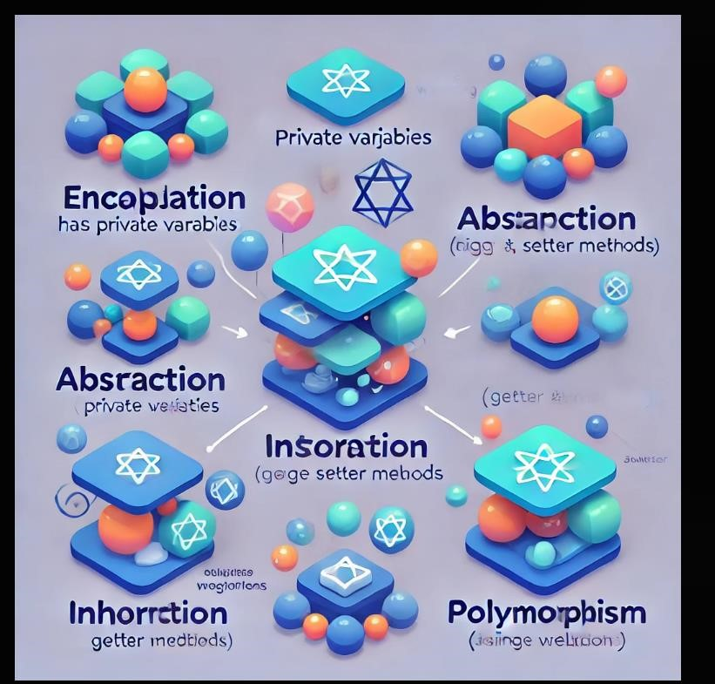
Figure 2.1 Concept of OOPS

2.3 JDK (Java Development Kit)

A Java language internship typically involves a combination of hands-on coding experience, mentorship, and training in various aspects of Java development. Here are some common components you might encounter:
Java Fundamentals: Learning the basics of Java, including syntax, data types, control structures, and object-oriented programming principles.
Frameworks and Libraries: Exposure to popular Java frameworks like Spring or Hibernate, which are commonly used for building web applications and managing data.
Development Tools: Familiarization with Integrated Development Environments (IDEs) like Eclipse or IntelliJ IDEA, version control systems (like Git), and build tools (like Maven or Gradle).
Database Interaction: Understanding how to interact with databases using Java, often involving SQL and tools like JDBC.
Web Development: Learning about building web applications with Java, including servlets, JSP, and RESTful services.
Code Reviews and Best Practices: Participating in code reviews to learn from feedback, adhering to coding standards, and understanding software development methodologies like Agile.
Real-World Projects: Working on actual projects, either individually or as part of a team, which helps apply what you've learned in a practical context.
Soft Skills: Developing communication, teamwork, and problem-solving skills, which are crucial for professional development.
Mentorship: Regular check-ins with mentors who provide guidance and support throughout the internship.
Overall, the goal is to build both technical and professional skills in a supportive environment.

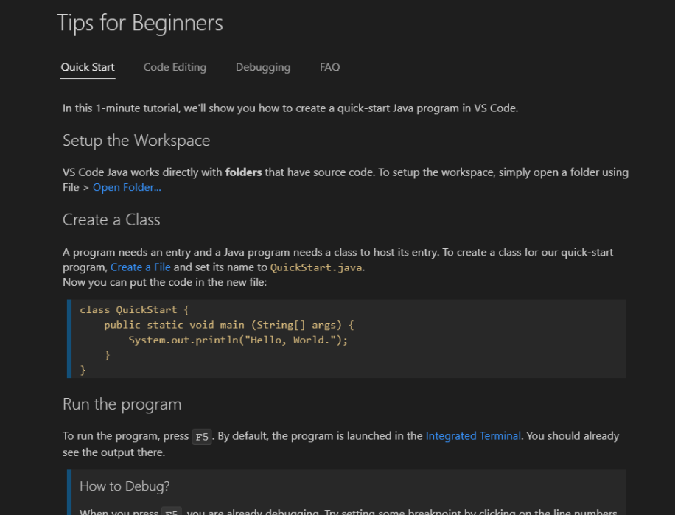

Fig: 2.2 Java code

Chapter 3 Results and Discussion

3.1 Currency Convertor Project
Swing is a part of the JFC (Java Foundation Classes). Building Graphical User Interface in Java requires the use of Swings. Swing Framework contains a large set of components which allow a high level of customization and provide rich functionalities, and is used to create window-based applications. Java swing components are lightweight, platform-independent, provide powerful components like tables, scroll panels, buttons, list, colour chooser, etc.
In this article, we’ll see how to make a currency converter which includes conversion between INR and Dollar. Two text fields are implemented with the labels Rupees and DollarCode:-
CODE:=
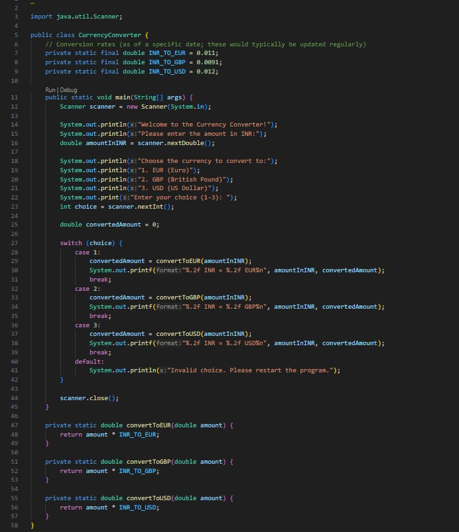

Fig 3.1 Input code
OUTPUT:=

/

Fig-3.2 Output of Currency Convertor

3.2 Attendance Management System project
Attendance Management System is software developed for daily student attendance in schools, colleges and institutes.
It facilitates to access the attendance information of a particular student in a particular class.
The information is sorted by the operators, which will be provided by the teacher for a particular class.
This system will also help in evaluating attendance eligibility criteria of a student.
The purpose of developing attendance management system is to computerized the tradition way of taking attendance.
Another purpose for developing this software is to generate the custom report at the end of the session or in the between of the session.
Another reason for developing this project is to enhance our learning skill and applying the application in the required area.
The proposed system should be user friendly, the retrieval and storing of data should be fast and data should be maintained efficiently. Moreover the graphical user interface should be provided in the proposed system, which provides user to deal with the system very easily. The proposed system requires very less paper work. All the data is feted into the computer immediately and
CODE:=
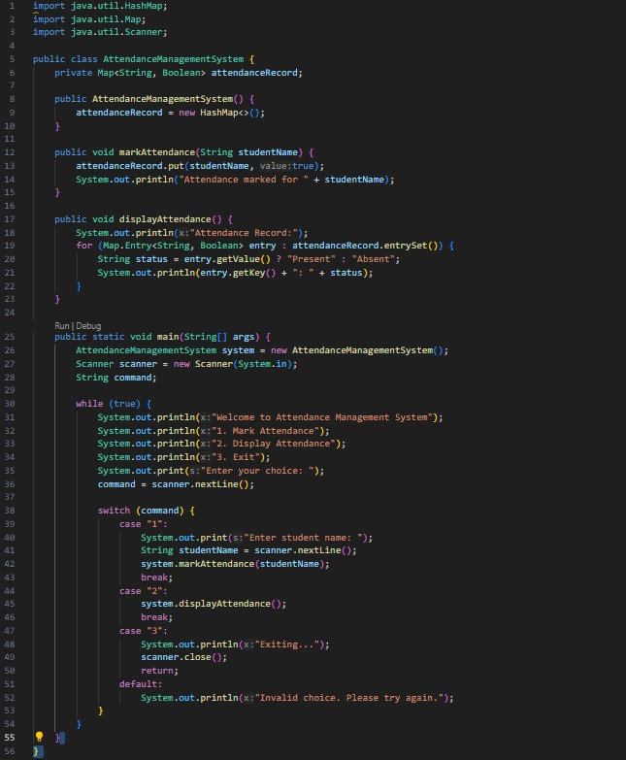
OUTPUT:=
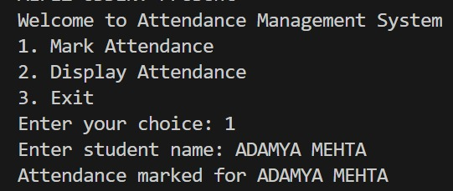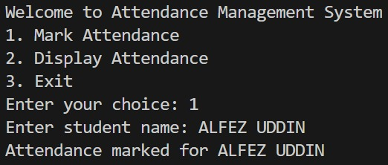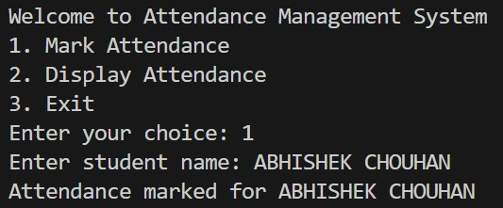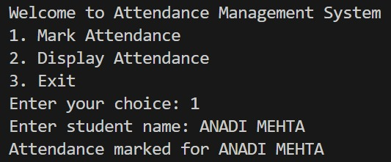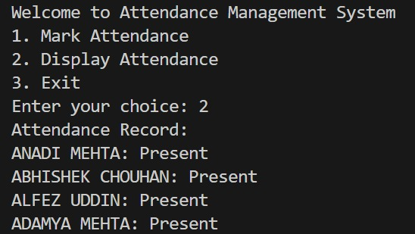

Fig-3.3 Output of Attendance Management System

Chapter:4 Conclusion and Future scope
4.1Conclusion:
A Java internship provides a valuable opportunity for aspiring mobile developers to gain handson experience in building cross-platform applications using Google's versatile UI toolkit. Through this program, interns can develop essential skills in app design, state management, and API integration, while working on real-world projects that prepare them for the tech industry. With mentorship and collaborative learning, participants not only enhance their technical capabilities but also build a strong foundation for a successful career in mobile app development. The Java internship is ideal for those passionate about mobile technology and eager to contribute to innovative app solutions.
a Java internship provides a comprehensive and immersive learning experience for aspiring developers to master cross-platform app development using Google's powerful UI toolkit. By working on real-world projects, interns gain practical skills in building responsive, highperformance applications for Android, iOS, and web platforms. The program emphasizes crucial aspects such as user interface design, state management, and API integration, while also fostering problem-solving abilities and coding best practices. With guidance from experienced mentors, interns can refine their technical skills and gain a deep understanding of Java Languageworkflows, from design to deployment. This hands-on experience not only boosts technical competencies but also enhances career readiness, making it an ideal stepping stone for anyone passionate about mobile technology and looking to secure a role in the fast-evolving tech industry. The internship serves as a launchpad for participants to create innovative solutions, develop a robust portfolio, and establish a strong foundation for future success in mobile app development.
4.2 Future Scope:
The future scope of Java, Google's open-source UI toolkit, looks exceptionally promising as it continues to revolutionize the app development landscape with its "write once, run anywhere" approach. Designed for building natively compiled applications across mobile, web, and desktop from a single codebase, Java offers seamless cross-platform development, which is becoming increasingly essential in today’s fast-paced digital world. With the growing demand for efficient, cost-effective, and time-saving app development solutions, Java is well-positioned to dominate the cross-platform development market. This framework enables developers to create high-quality, performant applications that deliver a native-like experience, thanks to its use of the Java programming language, which compiles into native code. The ability to share a single codebase across multiple platforms significantly reduces development time and costs, making it a preferred choice for businesses aiming to reach a broader audience without maintaining OCTarate codebases for different platforms. As a result, Java is set to become a mainstream tool in the app development industry, driving the future of mobile and multi-platform applications.
Java’s expanding ecosystem and community support play a crucial role in its future growth. The framework has a rapidly growing library of packages and plugins that allow developers to implement various features with ease, from simple utilities to complex integrations like payment gateways and social media APIs. The active and enthusiastic community continuously contributes to its ecosystem, providing updates, plugins, and open-source projects that further simplify development. The involvement of Google in maintaining and enhancing Java ensures regular updates and new features, keeping the technology aligned with modern development trends. This support, combined with an increasing number of Java-focused events, workshops, and learning resources, is creating a robust developer community that further fuels its adoption. The rise of skilled Java developers will also lead to more organizations considering it as a viable option for their projects, thereby reinforcing its position in the market.
Originally designed for mobile app development, Java's capabilities have extended to web and desktop platforms, offering a comprehensive solution for multi-platform app development. Java for Web and Java for Desktop are. This multi-platform support positions Java as a unique framework capable of targeting mobile, choice for web development due to their ability to offer offline capabilities, push notifications, and a native-like experience.

Appendix A

DAILY DIARY

Name of the Trainee: Awais Qureshi College: WalMart
Industry / Work Place: Online Day No.: 1-7 Week No. 1
Department / Section: Java Development Date: 1/10/2024

Week 1: Getting Started & Basics
Day 1 (1 OCT 2024)
- Tasks Completed: Set up the development environment and created a basic "Hello World" app.
- Challenges Faced: Issues with Android Studio’s AVD setup, resolved by checking system configurations.
- Lessons Learned: Basics of Java widget tree; difference between Stateless and Stateful widgets.
- Goals for Tomorrow: Begin designing a basic layout using Java widgets.

Day 2 (2 OCT 2024)
- Tasks Completed: Built a basic layout using Container, Column, and Row widgets; created a simple login screen.
- Challenges Faced: Struggled with padding and alignment of widgets.
- Lessons Learned: Learned layout properties like padding, alignment, and main Axis Alignment.
- Goals for Tomorrow: Explore navigation and screen transitions.

Day 3 (3 OCT 2024)
- Tasks Completed: Implemented basic navigation using Navigator and Material Page Route; created a secondary screen.
- Challenges Faced: Initial issues with data passing between screens.
- Lessons Learned: Gained insights into named routes.
- Goals for Tomorrow: Learn about state management basics using set State.

Day 4 (4 OCT 2024)
- Tasks Completed: Started building a to-do list app; used set State to manage task addition.
- Challenges Faced: Understanding when to use set State efficiently.
- Lessons Learned: Importance of state management and how set State updates the UI.
- Goals for Tomorrow: Complete the task of Currency Convertor Project

Day 5 (5 OCT 2024)
- Tasks Completed: Currency Convertor
- Challenges Faced: Managing task states for editing without breaking the app.
- Lessons Learned: More comfortable with state management; learned about data persistence using local variables.
- Goals for Tomorrow: Start exploring packages and plugins.

Day 6 (6 OCT 2024)
- Tasks Completed: Installed and integrated some basic plugins (shared preferences for data persistence).
- Challenges Faced: Issues with package installation and configuring dependencies.
- Lessons Learned: Learned to manage package dependencies and use Java plugins.
- Goals for Tomorrow: java tools and there uses

DAILY DIARY

Name of the Trainee: Awais Qureshi College: WalMart
Industry / Work Place:ONLINE Day No.: 7-14 Week No. 1-2
Department / Section: App Development technology Date: 7/10/2024

Week 2: Animations & Advanced Widgets Day 8 (7 OCT 2024)
- Tasks Completed: java tools and there uses
- Challenges Faced: Understanding how animation controllers work.
- Lessons Learned: Learned about implicit animations and their use cases.
- Goals for Tomorrow: Work with explicit animations using Animation Controller.

Day 9 (8 OCT 2024)
- Tasks Completed: Explored explicit animations; used Animation Controller to animate widget properties.
- Challenges Faced: Managing animation lifecycles.
- Lessons Learned: Understood the animation lifecycle (initialization, disposal, etc.).
- Goals for Tomorrow: Explore more complex widgets like List View and Grid View.

Day 10 (9 OCT 2024)
- Tasks Completed: Implemented List View and Grid View for displaying data.
- Challenges Faced: Performance optimization with large data sets.
- Lessons Learned: Best practices for optimizing List View with builder constructors.
- Goals for Tomorrow: Learn about asynchronous programming with Java.

Day 11 (10 OCT 2024)
- Tasks Completed: Worked on asynchronous programming; used Future and async/await.
- Challenges Faced: Understanding when to use synchronous vs. asynchronous code.
- Lessons Learned: Importance of asynchronous programming in Java.
- Goals for Tomorrow: Integrate basic networking with http package.

Day 12 (11 OCT 2024)
- Tasks Completed: Implemented basic HTTP requests to fetch.
- Challenges Faced: Handling network errors and parsing JSON responses.
- Lessons Learned: Gained experience with Java’s http package and JSON handling.
- Goals for Tomorrow: Implement a feature to display data.

Day 13 (12 OCT 2024)
- Tasks Completed: Fetched and displayed List View.
- Challenges Faced: Managing loading states while fetching data.
- Lessons Learned: Best practices for handling API responses and loading indicators.
- Goals for Tomorrow: final project of Attendance Management System.

Day 14 (13 OCT 2024)
- Tasks Completed: Attendance management system project
- Challenges Faced: Setting up SQLite database and performing CRUD operations.
- Lessons Learned: Understood the importance of local storage and how to implement it.
- Goals for Tomorrow: Start learning about Java’s state management libraries.

